Design Research Study

Interview Research

Research conducted by Connor Radeloff

For my research I conducted interviews with potential users of a homework planner application. The research was a series of questions to gain an insight into what kind of user the participant was and to ask some simple questions about how they would use an homework planner application. The interviews were conducted on two university students, one interview was conducted in person, and one was conducted over online video chat. The interviews were short, simply looking for insight into what an potential users would like to see in this application. A key thing to note is that one interviewee actually said that they would never use an online planner, as they enjoy the always available, never offline pen and paper.

The participants in the interviews were asked what kinds of features they would like to see in the application. Between the two participants, both indicated that they wanted several things. First, both participants indicated that the application should be simultaneously easy to use and operate on a surface level for convenience, but should be very advanced with many options should the user want to, in order to accommodate the use case.

Another thing that both participants said needed to be included is options for themes, different layouts for viewing your calendar. Some other suggestions that seemed important to me were the ability to sync with google calendar and the ability to look at previous weeks, a “at a glance” list/timeline of upcoming assignments, modular layouts, so you can add and move around “modules” and the ability to link school gmail accounts.

**Research Method:** Open conversation with students regarding planners

**By Danny Giger**

In my research I found a number of interesting things. I conducted an open conversation with ten different students where I kept some bullet points to talk about, and let them lead the discussion. One thing that was common among students was that they simply don’t have a planner, or they usually buy one at the beginning of the year and don’t end up using. Their reason for this was usually because they got tired of carrying it around. Some people I talked to were already using what we intend our product to be, an digital application that can keep track of homework assignments. The most common application used was the default calendar application that is found on apple products. They said they liked it because they could see what homework assignments they have on their phone and on their computer. Some downsides to this was that casual events, such as concerts or birthdays do not appear any different than homework assignments do which can be confusing. Some suggestions that were offered was color coding by class. I did also find one person who uses a homework app that offers everything that our product intends do. For the rest, people who did not have any sort of planner, they said that if they had to choose between paper and digit, that they would choose digital. From my discussions, each one of these people made it clear that they have their phone on them all the time, and the ability for that to double as a planner was a huge plus. I directed the conversations to see what they would like to see in a digital “planner” of sorts. I was pleased to see that most people wanted what we intend to implement in our product. One feature commonly brought up in my discussions was the idea of getting sent reminders when homework assignments are due. When the conversations were coming to a close, and the participant began to talk less, I informed them of the product we intend to to build and asked their thoughts on it. All the feedback was positive, but one thing that was commonly brought up was that they didn’t want to be restricted to the design of our application. An example being that in physical planner you can draw a big star next to important assignments which visually stood out. I thought that was the most interesting finding throughout my research. I concluded that the application we make should be flexible for the user to have an aesthetically pleasing experience.

**By Yuehua Yang**

We also used the method of the online questionnaire to collect the data from other classmates. For this method, Yuehua Yang made the online questionnaire with the google form and send it to all the classmates from CSCI 3002. Since we are designing a homework tracker, students will be our main users. So to get answers from our classmates could be a great idea. Most questions from the questionnaire are about students’ using habits of the homework planner.

One interesting thing I found is that most students are currently not using any homework planner app. Most of the students checked canvas recently to schedule their homework.

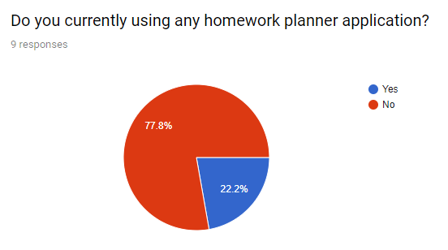

Also, another question asked that if students would benefit from a homework planner. More than 50% of the respondents agreed that they would benefit from a homework planner.

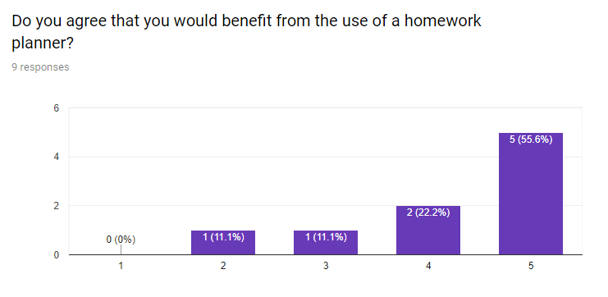

These two questions mean our homework planner could be significant for a lot of students since they are not using any homework planner and they could get benefit by using one.

Another interesting thing I found is from my question asking what function the user need that is not included in the current homework planner(such as canvas). One respond said the homework planner should have some way to show the most urgent tasks first and the urgency should determine by due date, difficulty and an estimated amount of time it will take. I think this information is very important for us. It could be one direction of the improvement and make our tracker unique.

**Group Reflection**

All group members were present over a Skype call.

In our group reflection, we determined that our results generally agreed with each other. We all agreed that the app needs to have a customizable calendar layout, reminders for when assignments are due, and the application must have a visually pleasing look that is personalizable to the users needs. Our findings also agreed that if the application had enough useful features, that many people would be interested in using the product, and would even consider switching over to the digital platform from a physical planner.

Based on this data it is clear that the design and layout of the application is extremely critical in order to capture and retain new users. The ease of use of the product is also extremely important, as if the usage is challenging or more inconvenient than a physical planner then users will not stay to use the platform.

The data collection methods were all useful, and provided pretty much the same amount of data and reached the same conclusions. The in person talks and interviews may have been more useful for this data collection round, however the surveys may become more useful when data collection for specific elements of the UI or UX appear, as that will provide more numerical and analytical data.

More data collection will become useful as ideas solidify and UI and UX elements begin to arise. However, for now, not much more data collection seems to be needed.

**Appendices**

Connor Radeloff, Interview

Questions:

1. What kind of student are you? (University, High School, etc.)
2. We are designing an app to help you plan out and organize your homework and assignments. Do you use a planner or calendar to help organize your assignments?
3. If you use a physical planner would you consider using a service specifically designed to help you organize your assignments? What would make you consider switching over?
4. What are some features you believe should be included in such an application? Basic and advanced/impractical features are fine.
5. On what platforms do you think would you use this application on primarily?

Yuehua Yang, online questionnaire

Questions:

1. Do you currently using any homework planner application?
2. If you don't, describe how do you schedule your homework assignment.
3. If you do, rate the scale from 1 to 5 to show how often do you check your homework planner.
4. Do you agree that you would benefit from the use of a homework planner?
5. How often do you want to get the remind from a homework planner?
6. How long do you do your homework every week in your current semester?
7. Do you want to get the upcoming assignment remind everyday from the app even there’s still a long time from the due date?
8. What function do you use most frequently in the homework planner application(if you are using one)?
9. What function do you want that is not included in your current homework planner?

URL link of the questionnaire: https://goo.gl/forms/vSP5fmhYA1zFGtB32